Poker dataset Decision tree report

1. 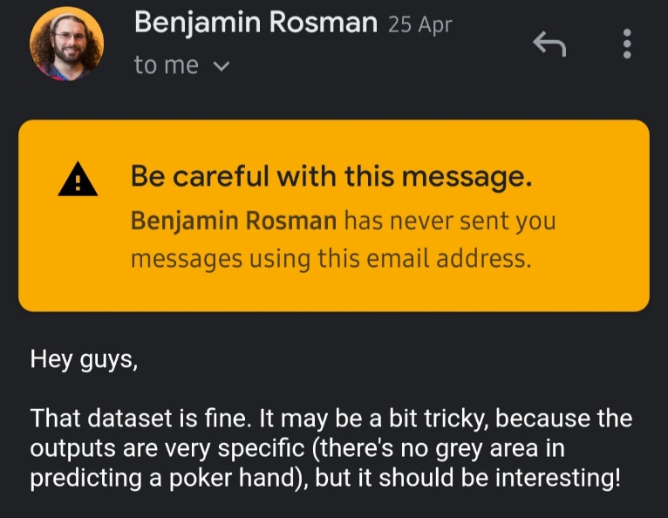Boilerplate dataset description, with all the attributes and the class of the poker hand… note that selection was called interesting in an email by Benjamin Rosman (email screenshot should be attached)
2. For the decision tree after the standard processing which included reading the data from the text files (using data reading helper classes) then splitting it along the lines of attributes and results. The dataset came with a prepared separation of data into testing and training sets, which were 25010 and 1 000 000 respectively, we then further split the 1 000 000 testing into 500 000 validation and 500 000 blind testing sets. Given that the data was given with raw attributes about suit and rank it was decided that more explanatory attributes would be needed in order to classify the given poker hands quicker. So the training data set was put through an algorithm which determined if the following could be found in the collection of ten attributes: consecutive values (if all the cards were consecutive regardless of order, for detecting straights), high ranks (if all the cards were royal in rank to better determine royal flushes), any number of duplicates (for finding pairs, two pairs, three of a kinds, and four of a kinds), and if the cards had the same suit (in order to find flushes). These new attributes were then used for the building of the tree and the inference of new data points.
3. Naïve Bayes, Decision Tree, and Neural Network

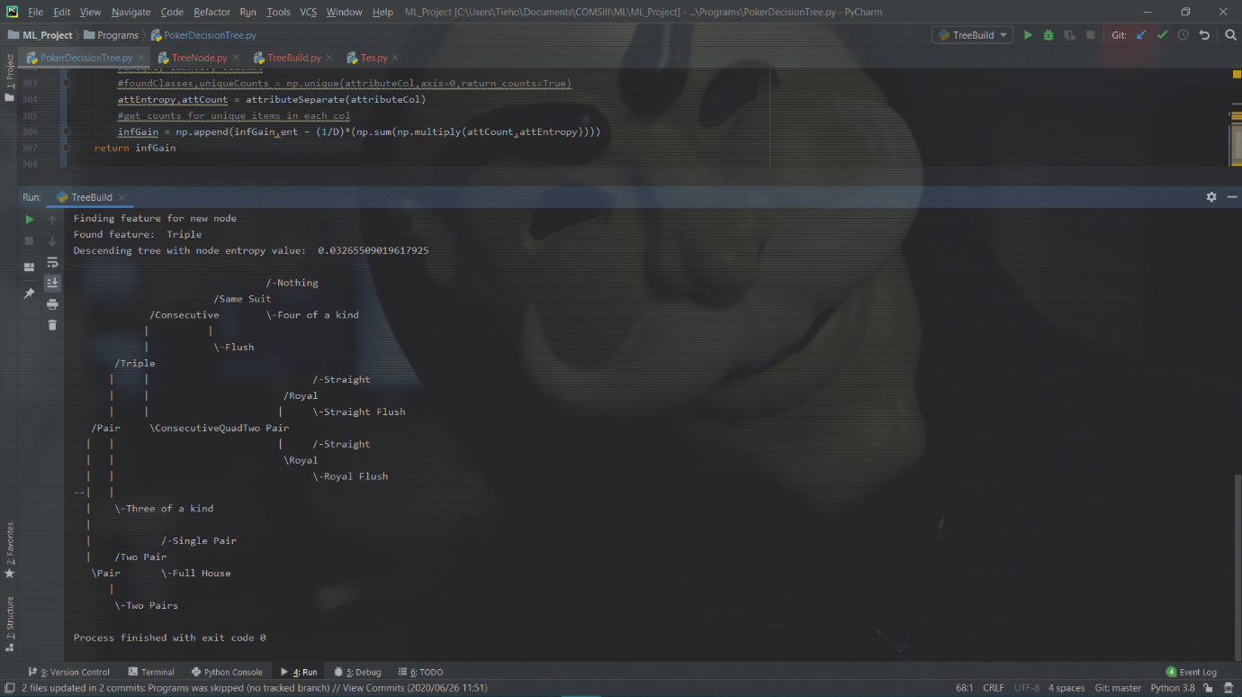

Figure 1: Tree drawn by algorithm

Decision Tree – Have yet to test the proper test set, still stuck on 0% for the validation set because my inference is trash. I don’t want to die; I don’t want that at all. Given that the decision tree was purely classification hyperparameters were not required. And this is the section where you want the confusion matrices. I see that, I see you and I curse Corona with my every breath. Also if I get a confusion matrix in the next… 10 minutes I’ll throw in some other equations.

1. Since each group member handled a single methodology no one member can speak to how well they compare. This section will be about the decision trees. The decision tree presents as the natural solution for classifying a poker hand as one can simply check if they have what is necessary to complete a hand and move down the ranking as they do not. The implementation, however, proved difficult. The treenode structure which simplified the drawing of the tree made passing of data rather tedious and led to certain machine precision errors that lead to higher confusion from the algorithm. The highest recorded scores are coming from the neural network on some 49% tip.

# Neural Network Training on Poker Hand Classification Data

We chose to train a neural network to classify the data because the data has ten features. These features themselves have a large range (1-13). Neural networks are very good at adapting to extremely varied data.

There are two major attributes to each card in the five cards that compose a hand. There’s the rank and the suit of the card. We found that the suit only matter in 3 out of the 10 classifications of a hand. This led us to put more preference on the rank of the cards.

The training data was split into a rank array and a suit array. Two neural networks were trained with one using the rank data and the other using the suit data.

Since 50.117739% of the results sat in the first class and 42.256903% sat in the second class we tried to level the data to account for the other 8.6%. This later proved ineffective because it put too much weight on the 8.6% that rarely showed up in the set.

We chose a deep network for the rank neural network because of the 7 different classes it had to classify. The shape that best suited it was [5,15,10,15,8,1]. After a couple of tests the best learning rate for the rank neural network was 1.2.

This was the confusion matrix after training:

[5., 0., 0., 0., 0., 0., 0., 0., 0., 0.]

[0., 5., 0., 0., 0., 0., 0., 0., 0., 0.]

[0., 0., 5., 0., 0., 0., 0., 0., 0., 0.]

[0., 0., 0., 5., 0., 0., 0., 0., 0., 0.]

[0., 0., 0., 0., 5., 0., 0., 0., 0., 0.]

[0., 0., 0., 0., 0., 0., 0., 3., 2., 0.]

[0., 0., 0., 0., 0., 0., 5., 0., 0., 0.]

[0., 0., 0., 0., 0., 0., 0., 5., 0., 0.]

[0., 0., 0., 0., 0., 0., 0., 1., 4., 0.]

[0., 0., 0., 0., 0., 0., 0., 2., 3., 0.]

Correct Percentage: 78.0

Wrong Percentage: 22.0

We used the shape [5,8,6,4,1] for the neural network of the suits. The learning rate was 1. This proved very effective as we were able to consistently train a neural network that could accurately classify the suit of each hand.

[5., 0., 0., 0., 0., 0., 0., 0., 0., 0.]

[0., 5., 0., 0., 0., 0., 0., 0., 0., 0.]

[0., 0., 5., 0., 0., 0., 0., 0., 0., 0.]

[0., 0., 0., 5., 0., 0., 0., 0., 0., 0.]

[0., 0., 0., 0., 5., 0., 0., 0., 0., 0.]

[0., 0., 0., 0., 0., 5., 0., 0., 0., 0.]

[0., 0., 0., 0., 0., 0., 5., 0., 0., 0.]

[0., 0., 0., 0., 0., 0., 0., 5., 0., 0.]

[0., 0., 0., 0., 0., 0., 0., 0., 5., 0.]

[0., 0., 0., 0., 0., 0., 0., 0., 0., 5.]

Correct Percentage: 100.0

Wrong Percentage: 0.0

The rank neural network had an average accuracy of 77% while the suit neural network had an average accuracy of 98%.

These neural networks then provided input into a third neural network that processed the data and reported a final guess. The shape for the final neural network was [2,16,8,4,1]. With the learning rate set to 1, the neural network had an average accuracy of 10%. It was polarized to account for the 8.6% of the varied data.

The best result we got was training a neural network with the full training set. The neural network’s learning rate was set to 1 and the network shape was [10, 8, 6, 4, 1]. We trained the network with varying training iterations but they did not make any difference in the accuracy of the network.

The confusion matrix for this network was:

[24905., 0., 0., 0., 0., 0., 0., 0., 0.]

[21255., 0., 0., 0., 0., 0., 0., 0., 0.]

[2406., 0., 0., 0., 0., 0., 0., 0., 0.]

[1040., 0., 0., 0., 0., 0., 0., 0., 0.]

[218., 0., 0., 0., 0., 0., 0., 0., 0.]

[104., 0., 0., 0., 0., 0., 0., 0., 0.]

[62., 0., 0., 0., 0., 0., 0., 0., 0.]

[9., 0., 0., 0., 0., 0., 0., 0., 0.]

[1., 0., 0., 0., 0., 0., 0., 0., 0.]

Correct Percentage: 49.81

Wrong Percentage: 50.19

Since most of the results are situated in the first and second class, the network was skewed to the first class. Guessing 0 for all the tests gave an accuracy of 49.81%. This approached was smarter than the other optimization strategies that we tried.

The sigmoid function was used to create all the neural networks mentioned above.